# Service Manager Utility Application

## Problem Statement

In Oasis Loyalty suite consist of decent number of services. Also we have man branches each branch has multiple environments and each environment has all the services installed on the servers. As of now we must physically log in to machine by taking remote and start/stop/monitor the services. Limitation of the server is that it can have only 2 users to be logged in parallelly which can be a bottleneck. Also logging on to multiple machines can lead us to get our accounts locked in case if we forget to logout.

## Architecture

Client – Server Architecture 🡪 This application will have two parts

* Service (Asp.net – WebApi using Restful service)
* Client (Single Page Web Application developed in Angular)

## Service

* Modules
  + Monitoring Services
  + Updating State of Services
  + Logging
  + Security

### Monitoring

We will be able to monitor services installed on any machine (client/user has access) without physically logging-in to machine.

* **Get All Services 🡪** User can request to get all the services which are installed on the requested machine(s).
* **Get Services By Name** 🡪 User can request to get specific service which is installed on the requested machine(s).

**Use Case Diag**

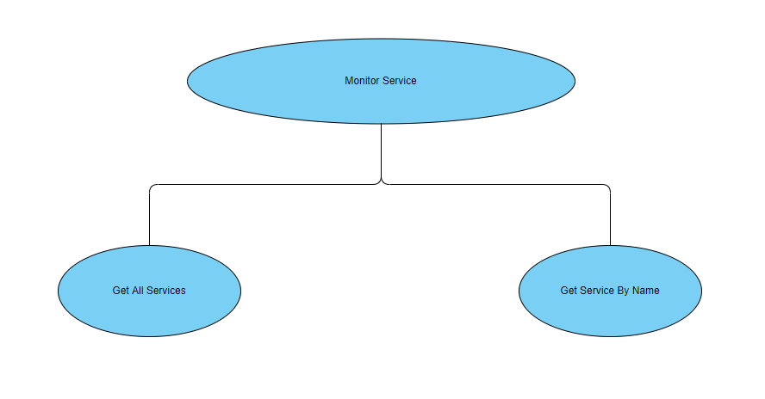

**Note:-** Operations mentioned in the diagram supports multiple machines in single request.

### Update State of Services

We will be able to update status of services installed on any machine (client/user has access) without physically logging-in to machine.

* **Start Service** 🡪 User can start a service which is stopped or paused.
* **Stop Service**🡪 User can stop a service which is running.
* **Pause Service** 🡪 User can pause a service which is running.
* **Restart Service** 🡪 User can restart a service which is running.

**Use Case Diag**

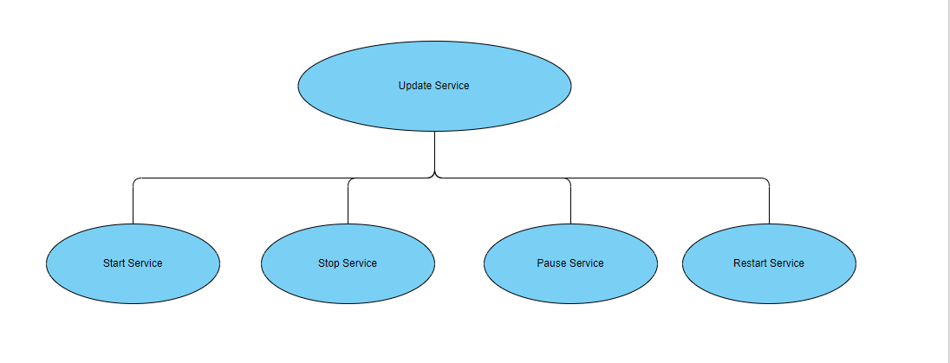

**Note:-** Operations mentioned in the diagram supports multiple machines in single request.

### Logging

We will be logging the request Users and the machine of request. Also, errors or exceptions (if any).

### Security

This utility will be equipped with ADGroup Directory Authentication so that only valid users can use this utility.

## Client

Yet to be started.